
AIRETAILS
2008

AIREDALE RESCUE STORIES
OF THE NORTHWEST REGION

Welcome to our first annual edition of AIRETAILS. Every rescue has a story. We hope you enjoy the stories of the rescue Airedales that we have chosen to bring to you this year in AIRETAILS.

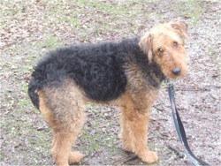
REX

Northwest Airedale Terrier Rescue (NWATR) is a 501 c (3) charitable organization formed with the purpose of
helping homeless Airedale Terriers in the northwest region. NWATR is an all volunteer organization. NWATR
operates under the code of ethics and guidelines of the Airedale Terrier Club of America’s rescue committee.
WWW.NWAIREDALERESCUE.ORG



REX

Our 2008 Rescue Poster Boy for his guts and Airedale Spirit as told in the story below.

The Story of Rex as submitted by the wonderful AireAngel who found Rex…

“I am a retired old guy that lives in the Sierra Nevada/Cascade foothills. It is more then rolling land, closer term is mountainous. There are communities here and there, with private forests used for lumber harvesting. I hike my dogs daily in these mountains. One day in October in the late afternoon I heard a mournful howl coming from a near by peak. It was of a dog in distress. I could not follow through with looking for it, as the area was remote and the light was dwindling. So I decided to return the next day but that proved to no avail, as the howling had stopped and the area was very large. I talked to the people living closest to the area, but nothing.

Approximately two months later on Christmas Eve day 2007, I was hiking as usual on the road past the residential land and went along the side of the mountain into the forested area. I had just gotten out of the car and the dogs ran off up a side trail above me. Looking up and into the morning sun I saw a stray dog. I called my dogs back to the Jeep and put them inside, then walked up the side trail to approach the dog, but it was gone. It had gone down the hill to my car. The stray wanted to be with my dogs. He was so pathetic, his coat was in dreg locks and his eyes were caked with puss, weeping and sunken. As I reproached him he again went down the hill away from me and stopped. I called and he would try and focus on me, but I could see he was mostly blind. I could not follow because of the steepness of the land and the brush. I left to get food and water. When I returned he was gone.

Christmas day I went back up to look for him. As I approached the last homes on that road there he was in the road. He was drawn from the mountain to the sounds of dogs. I was able to feed and water him, But he was not having anything to do with me touching him or putting a noose on him etc. But he drank and ate as much as I could give him. I left to find a cell signal and called the first home to tell them, that he was on their property. But they were leaving for Christmas Dinner elsewhere. I returned to the dog, scared he had moved back up the road and into the brush. I then went to the second home and told them the dog was on their property and if he came down to call me. The morning after Christmas I got a call and went to pick him up. They had him in a pen where they would keep their dogs. He ran away from me but he was gentle yet fearful. I scooped him up and took him home.

He was a mess. I cleaned 48 large ticks from him. Cut the dreg locks from him and took him to the vet two days after Christmas. The poor fellow was blind in one eye and partially in the other. He was so skittish and frightened of me, of noises, of movement around him. But slowly he would hear my voice and his tail would wag and he would be joyful. This dog after a minimum of two months lost in a mountain lion infested woods, after suffering freezing rain and no or little water and no food managed to find joy. When his heart found and expressed this joy, so did mine. I was told to take the dog to the pound, but all I could do was to think about how I could stop him from going totally blind. How can I get the fear from him and patch up the injury to his soul. My mind could not imagine how he was abused or why anyone would have allowed this to happen. But that was the past and now is the start of his future.

The first miracle was him finding me and me finding him, but the next miracle was me finding Northwest Airedale Terrier Rescue, Coordinator Connie Turner, Salem, Oregon, at their website: http://www.nwairedalerescue.org/ .

Connie gave me hope from the first conversation; this dog would have a better life and would find some type of medical help to, if not restore, to arrest the degeneration of his sight. Within days I found myself driving north from my home toward Connie and her friend, who were driving from the Salem OR area.

I put the dog in her car and could see even though it was stressed it was in the best of care. He needs a home where there is consistent love and maybe another canine friend to will be with him through his years. Rex needs are many. His joy of life will bring reward to his future handler.

For the life of me, I do not understand how this young mostly blind dog managed to move from one mountain to another in two months surrounded by mountain lions, freezing cold and with out water or food, then come to me and have this internal joy for living. “

Update: After being fostered by Connie and Gordon Turner , a wonderful man in Portland, Sean Cruz, took a personal interest in Rex, his story, and his plight and, after much preparation, has become Rex’s Aire-Dad for many years to come. Rex and his Dad spend their days in the halls of the Oregon State Legislature and, also, enjoy frequent visits to the river in Portland. Rex loves to “see” his foster mom and dad when they slip in for a visit while in the area. Rex is almost 100% blind in both eyes but is one of the happiest Airedales around thanks to everyone who came forward to help this Airedale in need. www.rexspage.blogspot.com

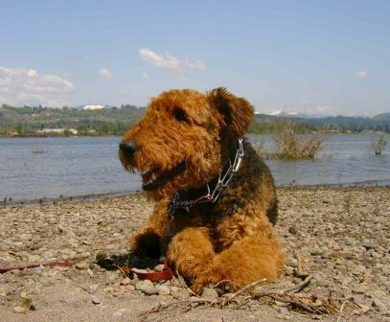

***Donations to Northwest Airedale Terrier Rescue are used to provide resources and funds to our rescue volunteers and to support our efforts to help temporarily homeless Airedales in the northwest region. Donations can be made by check and mailed to 1958 8th Ave West, Seattle WA 98119 OR can be made via PayPal at our website at www.nwairedalerescue.org.***

Airedales Rehomed by NWATR twelve months ended July 31, 2008:
Chloe, Joey, Zena, Axel, Angel, Fritz, Sandi, Ozzie, Elliott, Charley, Kali, Wilson, Bentley, Maggie, Annie, Ginger, Ranger, Brock, Boris, Sadie, Paisley, Chewy, Ed, Major, Gromit, Mamma, Clyde, Juno, Addie, Curly, Jassmine, Shasta, Axel, Bella, Maxmillian, McHeath, Maggie, Roger, Tess, Goldberry, Buffy, Toby, Virginia, Max, Danny, Rigsby, Gabby, Harry, Gladis, Lexi, Gracie, Oliver, Forest, Sir, Dulcinea, Maggie, Wynn, Bobbie, Dorothy, Oscar, Rex, Tina, Peaches, Lucy, Freeburg, Ann Marie, DeDe, Fred, DeLake, Andy, Buffy 2, Milly, Ruby Tuesday, George, Maggie, Hank, Winslow, Harry, Mike, Carry, Ruthie, Harpo, Mary Lou, Maisly, Bentley, DeCon, Misty, Sophie.

THANK YOU TO ALL AIREANGELS WHO HAVE RESPONDED TO OUR CALLS FOR HELP. GETTING AN AIREDALE RELEASED FROM A SHELTER, TRANSPORTING, ALL THAT GOES INTO FOSTERING AN AIREDALE TO GET READY FOR A NEW FOREVER HOME, GROOMING, WEEKLY SHELTER CHECKS, HOME CHECKS, OWNER COUNSELING, ETC. ALL REQUIRE LOTS OF VOLUNTEER TIME AND WE THANK YOU SO MUCH!!!!!

EIGHT WEEK OLD PUPPIES
In July, we got a call from the Canyon County Humane Society in Nampa, Idaho requesting immediate assistance with five purebred Airedale Terrier puppies, abandoned at the shelter on a day they were closed. By the next day, we had volunteers lined up to pick up the pups from the shelter and to transport them to the Turners in Salem, Oregon for care and evaluation prior to placing in approved homes. Shelter representatives later determined the breeder of the pups and found out that because the breeder was unable to sell these last five puppies he tried to sell them at the local WalMart that morning, thought the 100 degree day was too hot, so dropped the box of puppies at the closed shelter on his way home. Luckily, a shelter volunteer drove past the shelter that day and noticed the box outside of the building, so stopped to investigate. The breeder was later sited by animal control for animal neglect. The lucky homes that ended up with these five beautiful Airedale kids can be seen on the Happy Tails page on our website at www.nwairedalerescue.org.
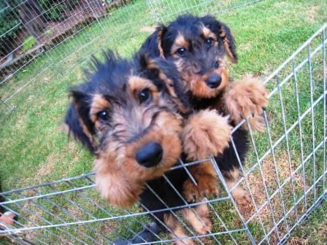

A BIG AIREDALE THANKYOU TO THOSE OF YOU WHO HAVE DONATED FUNDS TO NWATR:
Sally Tange, Stantey Niemiec, Susan Purdy, Mary Pillar ,Zia Gipson, Teri Akin, John and Kaye Jean Thompson, Megen Opsahl, Connie Cservenyak, Randy Rogers, Fred Church, Alicia Nelson, Rebecca Winter, Juanita Bott, Erin Raney, Doug Schurman, Gene Hartman, Phyliss Huckabee, Mary Tarkington, Lindsay Myers, Mary Edgecomb, Chris and Kay Johnson, Robert and Carol Geweke, Deanna Vick, Susan Broaddus, Paula Estep, Kim Thompson, Heidi Thompson, William Woodland, Susan Widmar, Dave Condon, and a special thank you to Helori Graff who donated her life collection of Airedale Terrier arts and crafts for resale in our online store (soon to be made available on our website). If we have inadvertently left any of our donors out, please let us know!

_____________________________________________________________________________________
Donations are vital in our efforts to help Airedales in need in the northwest region. We have a dream to some day have an Airedale sanctuary to act as a safe haven to meet, greet, groom, vet, evaluate, house, and place Airedales temporarily down on their luck. Did you know that shares of stock can be donated to a 501 c (3) charitable organization like NWATR and you can deduct the fair market value on your taxes? If you sell the stock yourself, you would need to know your basis and have to pay taxes on the gain. (WSJ 2008).
______________________________________________________________________________________
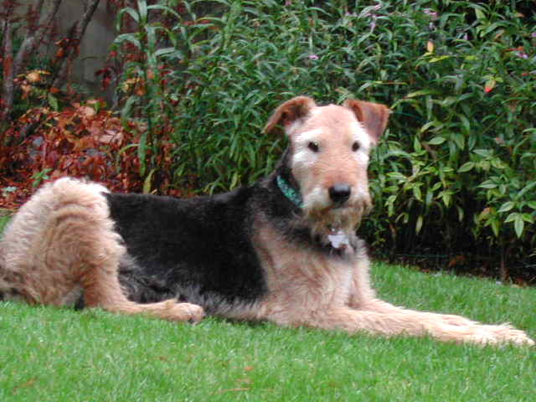
SANDI At 14 years old, Sandi came to us in late October after having to spend the last year on a short tether attached to a tree braving the elements of a harsh Eastern Washington winter. An AireAngel discovered her, took her home and called us; thinking we would not be interested in helping such a senior girl. Oh, but we all know the seniors are the best and we couldn’t wait to bring her into our rescue group and give her the best rest of her life possible! Her rescuer began seeing immediate improvement in her ability to climb stairs and play with the other dogs after vetting her and getting her on glucosamine supplements. Bruce Pennel and Connie Cservenyak coordinated her ride from near the Canadian border to Renton, Wa where Teri and Brian Bang fostered her until it was time for Sandi to cross the bridge. Sandi touched everyone who was lucky enough to meet her and help her in her new life. We all marveled at the daily progress she made in her health and stamina. Acupuncture, massages, and long gentle walks brought back the Airedale spirit in this girl. We grieve her loss but smile at her memory.

To research other breeds and to find local breed rescue contact information, visit the American Kennel Club website at www.akc.org.

*****Top Ten Reasons Airedales End Up In Rescue:*****

10. Did not match the furniture (kidding but we did hear this once)
9. Won’t come when called
8. Visits the neighbors (no fence)
7. Elderly owner wanted their one last Airedale
6. Knocks the kids over with tuck butt runs
5. Doesn’t like being alone during the workday
4. Small dog in family ticks off the Airedale
3. A move that doesn’t include the family Airedale
2. New spouse or new baby
1. Many breeders do not screen homes; only ability to pay

----------------------------------------------------------------------------------------------------------------------------------------------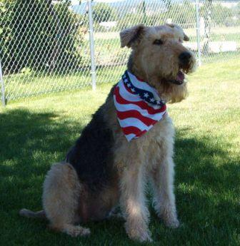HILIARY (DILLY BEARS)

Hiliary came to us last winter when her owners relocated with Microsoft to China. At thirteen years old, Hiliary had also kind of gotten lost in the shuffle with an adoption of a baby at her home. A bit frumpy from lack of grooming and a little depressed from loosing her home and her previous Airedale buddy, Hiliary blossomed with rescue volunteers, Dave and Gina Hardy in Spokane. They too know how special it is to take in a senior. Hiliary immediately loved her new Airedale brother and sister and found her youth again with playtime, toys and meeting other rescue Airedales that made their way through the Hardy home. Hiliary crossed the bridge in August but she will always be remembered as the sweet funny girl who loved life to the fullest.

CHARLEY
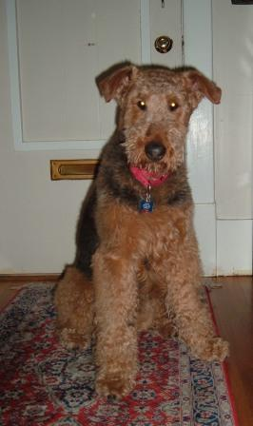

Dropped off at the Everett Animal Shelter by the only family he had even known two weeks before Christmas, 2007… Charley, at nine years young, is happy again with a loving family at Birch Bay, WA. The following poem is dedicated to him and all who were left behind at a shelter in hopes someone would adopt them in time:

I ADOPTED YOUR DOG TODAY

I adopted your dog today; The one you left at the pound; The one you had for seven years; And no longer wanted around.

I adopted your dog today; Do you know he’s lost weight? Do you know he’s scared and depressed? And has lost all faith?

I adopted your dog today; He wasn’t eating and had a cold; But don’t worry none; You’ve unburdened your load.

I adopted your dog today; Were you having a baby or moving away? Did you suddenly develop allergies; Or was there no reason he couldn’t stay?

I adopted your dog today; He doesn’t play and eat much; He’s very depressed, but he will learn again to trust.

I adopted your dog today; And here he will stay; He’s found his forever home
And a warm bed on which to lay.

I adopted your dog today; And I will give him all that he could need. Patience, love, security, and understanding; Hopefully, he will forget your selfish deed.

Author Unknown

Loui found himself in a rural animal control situation where a stray is normally put down to save time instead of trying to find a new home for the unfortunate walkabout. Loui was spotted by a local all breed rescue volunteer on her daily shelter check who immediately called NWATR and later that day pulled him from his death row cell. Chris, one of our AireAngels in N. Idaho, picked Loui (now Gromit) up and fostered him until he was later placed in a beautiful home in Bellevue, WA. His before and after pictures are below (there is always a beautiful Airedale under all of those unkempt curls and coat).
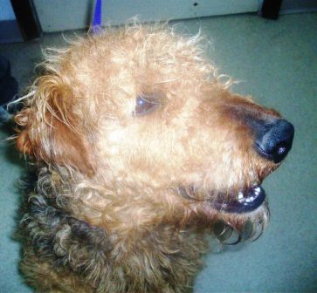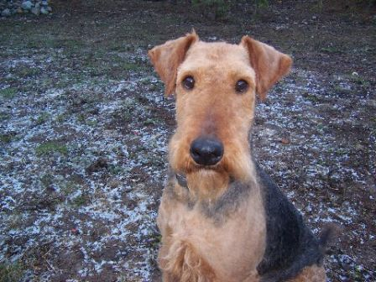

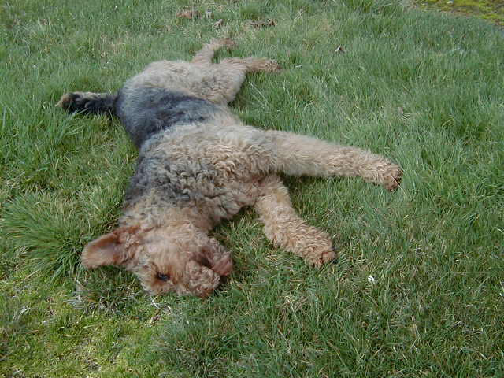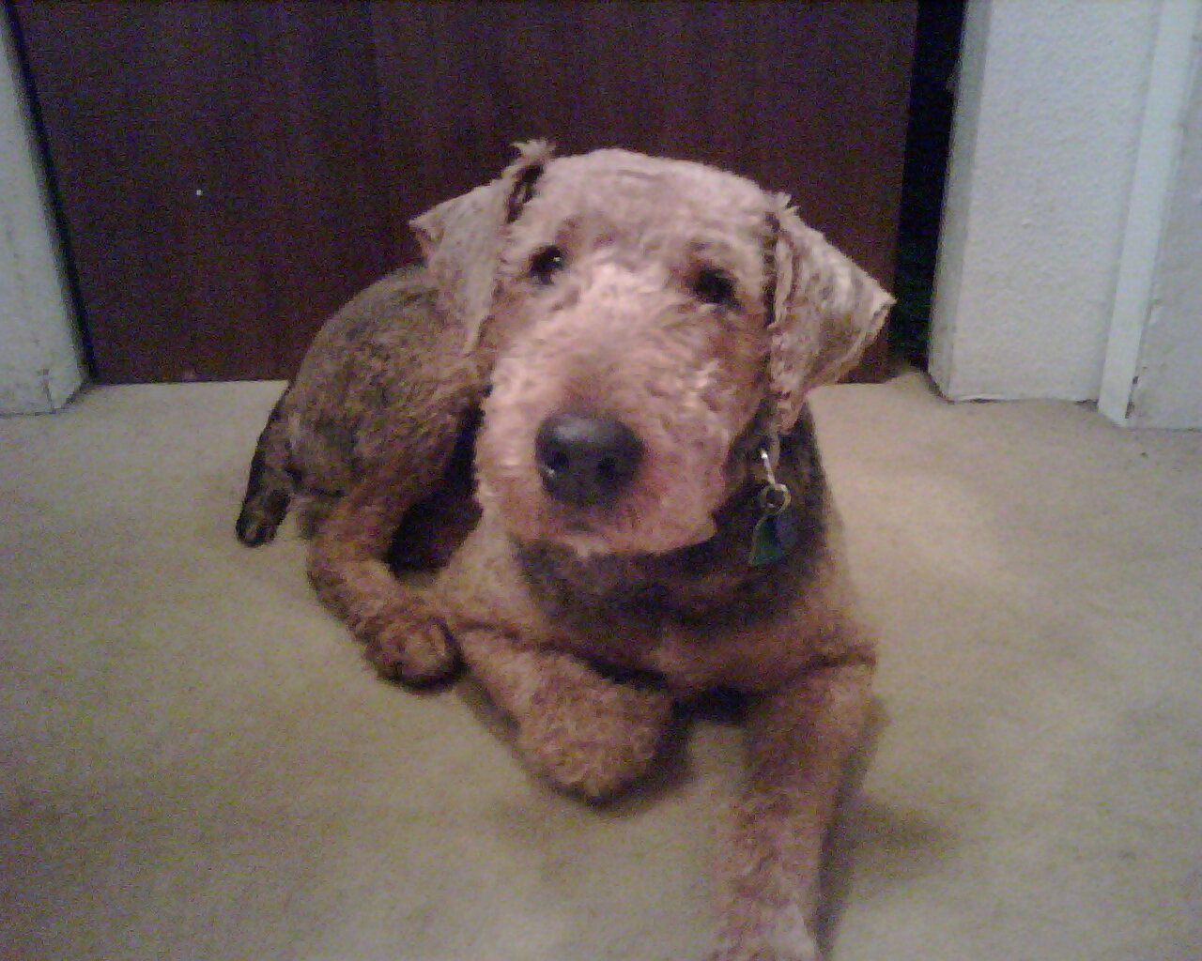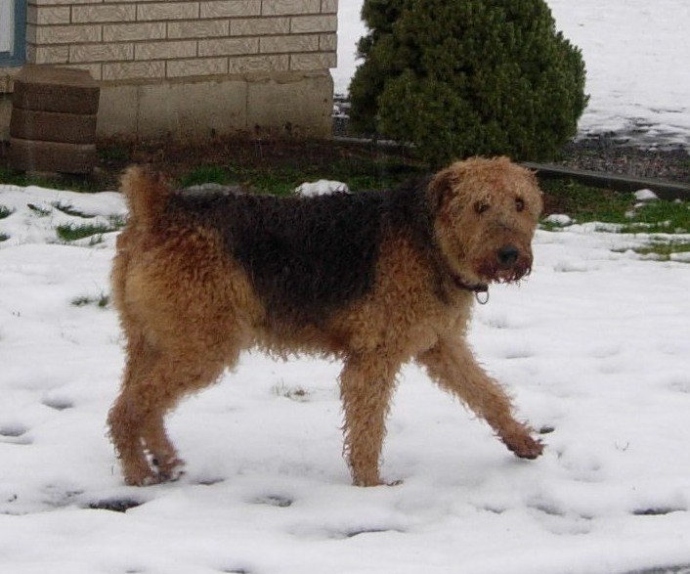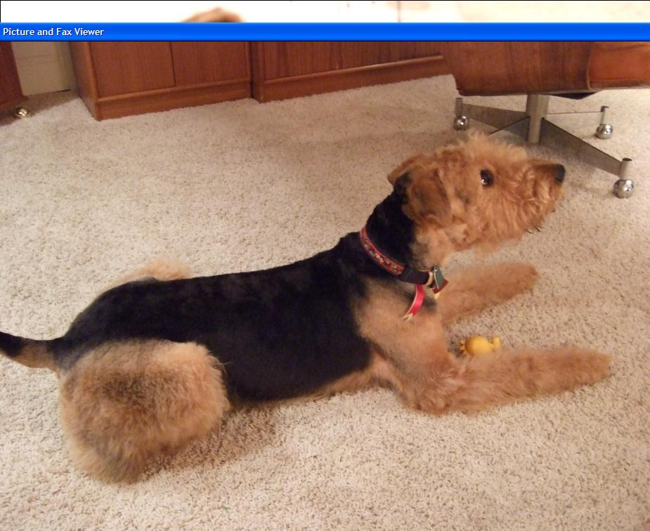

ANGEL AND AXEL…Ended up in small dirty cages at a local Spokane pet store which sells unsold puppies of local backyard breeders. An Airedale lover couldn’t bear to see their plight so purchased them and later picketed in front of the store to make people aware of the neglect these two endured while at the store. Angel and Axel are now in a wonderful Portland home living the life every Airedale deserves to have.

OZZIE…His Russian mom died and his dad never did like him too much so put Ozzie on Craigslist to find someone to come pick him up. A great lady got Ozzie and later called NWATR to have him rehomed properly. Ozzie is now in Olympia, WA with another Airedale and a loving family with lots of room to run and play.

ELLIOTT…Abandoned in Bothell, WA, a caring person took him to a local veterinarian who called NWATR. It was Christmas, 2007 and we were swamped so an approved applicant fostered Elliott and, of course, decided to adopt him.

SISSY…Abandoned in a farming community north of Spokane, SISSY found a home and a covered porch and decided to stay. The family’s German Shepard was not pleased with the new family member so NWATR was called to find her a new home. SISSY is living a wonderful life in Friday Harbor, WA.

GRACIE...Left alone in a horse stall after her mom was told by her husband that Gracie had to go and go now because she wouldn’t listen to him, Gracie’s mom called us and asked NWATR to take Gracie that same day. Rescue wheels started turning and Gracie was in loving hands by days end. This darling girl, now named Casey, is now in a loving home with wonderful retired couple in Vancouver, British Columbia.

AIRETAILS 2008
Airedale Rescue Stories Of The
Northwest Region

DID YOU KNOW?
*NWATR can be named in a pet trust in case of owner death?
*Hotspots can be helped with ½ cooked baked potato in food?
*Raisons, grapes and xylitol in sugar free gum and food kill dogs?
*Airedales should continually be socialized with other dogs?
*Fatty tumors can be prevented?
*Dogs should be fed twice a day and dish removed each time?
*Lawn pesticides and herbicides cause cancer in dogs?
*Instead of annual vaccinations, your vet should use the TITERCHEKTM ..test kit to check if your dog needs to be revaccinated?
***Over vaccinating your dog can cause serious health issues***



1958 8th Ave West
Seattle, WA 98119

